Index Cards 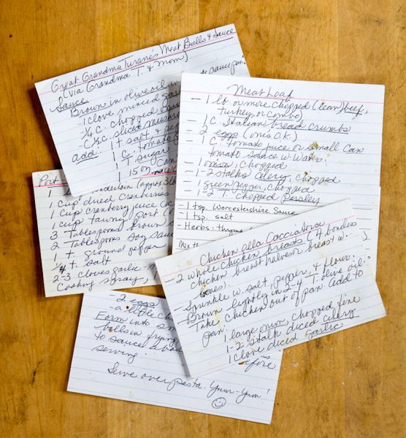

- Name – (nicknames, special pronunciations, etc.)

- Contact Information – (E-mail, phone number)

- Education and Career Goals

- Previous English Class (If at De Anza, give instructor name)

- Strengths and Challenges in English

- What experience do you have with Shakespeare if any?

- Personal Interests/Hobbies/Work

- Anything Else?

