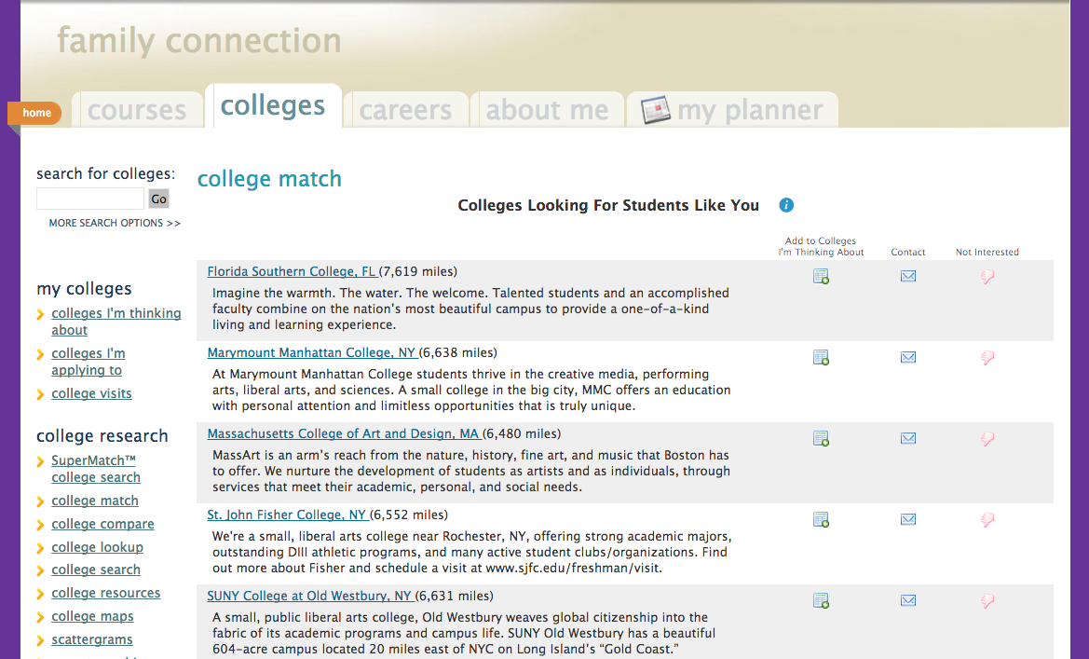

XYZ University targeting NY & NJ students:
NY Pizza? NY Bagels? You’ll find a new favorite taste in Washington, DC at Ben’s Chili Bowl, Old Ebbitt’s Grill across from the White House, or a specialty cupcake shop. Or check out Union Market's food hall with eat-in or take-out culinary wonders.

XYZ University targeting OH students:
While Ohio is the "Mother of Presidents," the official home of the current president is the White House--just minutes away from XYZ. Come to Washington to experience it for yourself!

XYZ College
Ernest Haycox wrote, “No sensible man watches his feet hit ground. He looks ahead to see what kind of ground they’ll hit next.” Sharpen your vision. XYZ College

Leland Stowe wrote, “An American will tinker with anything he can put his hands on. But how rarely can he be persuaded to tinker with an abstract idea.” Get the tools. XYZ College

Will Rogers said, “If stupidity got us in this mess, why can’t it get us out?” Find the escape route. XYZ College.

NY Pizza? NY Bagels? You’ll find a new favorite taste in Washington, DC at Ben’s Chili Bowl, Old Ebbitt’s Grill across from the White House, or a specialty cupcake shop.

targeting students in their home state (MS)
Want to stay true to your home state? XYZ U is right in your backyard. Challenging academics, competitive scholarships, and lots of activities! Whether you’re interested in ballet or baseball, medicine or music, XYZ U is the place for you!

XYZ University – specific message timed for May
It's graduation time! The big white tent is up in the quad and XYZ U is ready to launch new graduates into the world. These talented young professionals have not only earned degrees, they’ve also shaped the XYZ U community.

general
Looking at a warm-weather college with a private, prep-school feel? Florida’s premier Christian university awaits you. Our faculty is eager to help you succeed with coursework and with your goals in life. Visit soon.

focus on outcomes
With 100% of first-year students receiving scholarships & grants (averaging $17,625/yr) and 85% of new alums employed, an XYZ education is affordable and pays off! Our grads are 3 times more likely than average to find employment after college.

